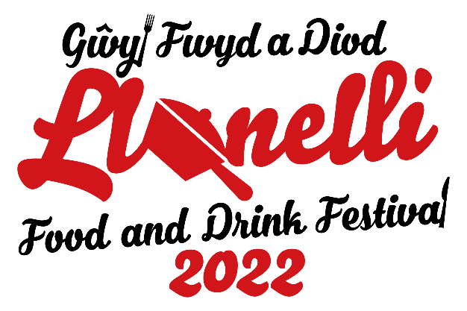
Llanelli Food and Drink Festival 2022 Application Form
Please note that due to high interest, all applicants will be put through a selection process and you may not be guaranteed a pitch.

Contact name: _____________________________________ Date of birth: ____________________
Business name: _____________________________________________________________________
Business address: ___________________________________________________________________
__________________________________________________________________________________
Email: ___________________________________ National Insurance Number: _________________
Phone number: ___________________________ Vehicle registration: ________________________
Please provide a brief description of your business and your products.
_________________________________________________________________________________
_________________________________________________________________________________
_________________________________________________________________________________
Do any of your products cater to the following dietary requirements?
Gluten-free / Dairy-free / Vegetarian / Vegan
Which of the following apply to you and your business?
New business (trading for 2 years or less) / Young trader (16-30 years old) / Welsh producer

Pitch details
A standard pitch is 3m x 3m and costs £15. Large pitches will cost £15 extra per additional pitch used (i.e. a 5m x 2m pitch will cost £30).
All traders must have their own gazebos/trailers in compliance with Llanelli Outdoor Market regulations. Gazebos, tables and chairs will not be available for hire.
Pitch size: _____________________ Pitch type: Gazebo / Trailer / Other: _______________
Category/s (please note no on-site alcohol to be sold): Street food / Produce / Alcohol

Electricity and equipment
I require electricity for an extra £15: Yes / No
Electrical equipment being used: ______________________________________________________
If yes, please confirm date of expiry: ___________________________________________________
Gas equipment being used: __________________________________________________________
If yes, please confirm date of expiry: ___________________________________________________

Documents
Please note that you must have £10 million public liability insurance coverage as per council terms and conditions. Your public liability insurance must be in date at the time of festival (Saturday 15th October). If your insurance is set to expire before the festival then you may attach your current insurance, however you must then forward your renewed insurance to us when you receive it.

I have attached a copy of my public liability insurance: Yes / No
Public liability insurance expiry date: ___________________________________________________
I have attached a copy of my food hygiene certificate: Yes / No
Please attach proof if you are awaiting inspection.
I have attached a copy of my risk assessment: Yes / No
You may use a pre-existing risk assessment.
A risk assessment template is available upon request.

Confirmation and payment
Please send your completed form to Ymlaen Llanelli on jade.evans@themeans.co.uk.
Successful applicants will be notified at a later date and will be sent payment details in their confirmation email. You must pay before the festival date to secure your pitch.
If you can no longer attend due to unforeseen circumstances, please let us know in advance and you will be issued a refund. No-shows will not be issued refunds.
Ymlaen Llanelli is a non-profit organisation. The money collected from pitch fees will be donated to local charity.

Please refer to the Market Terms and Conditions attached. These general rules are in addition to any Bylaws appertaining to the markets controlled by Carmarthenshire County Council.

